**Assignment 2**

**Functions**

* getDifficulty
  + Inputs: None.
  + Output: Difficulty level.
  + Description: This function gets the difficulty level from the user clicking a button with a difficulty “easy”, “normal”, or “hard”. The difficulty level will be used to determine how frequently Furball drops “fluffies” (hair balls).
* displayBackground
  + Inputs: None.
  + Output: None.
  + Description: This function displays the background image onto the canvas element in the page. It does not take any inputs and instead gets the canvas element directly; it has no output apart from displaying the background.
* drawFurball
  + Inputs: x and y coordinates where Furball will be drawn.
  + Output: None.
  + Description: This function draws Furball on the canvas over the background image. It takes the location where Furball will be drawn as x and y coordinates and uses them to draw Furball.
* drawHairless
  + Inputs: x and y coordinates where Hairless will be drawn.
  + Output: None.
  + Description: This function draws Hairless on the canvas over the background image. It is similar to the drawFurball function in that it also takes the location as x and y coordinates to draw Hairless.
* drawFluffy
  + Inputs: x and y coordinates where a “fluffy” (hair ball) that Furball drops will be drawn.
  + Output: None.
  + Description: This function draws a “fluffy” (hair ball) that Furball drops on the canvas over the background image. It takes the location of the “fluffy” as x and y coordinates.
* getFurballLoc
  + Inputs: The current location of Furball.
  + Output: The new location of Furball.
  + Description: This function determines where Furball will move to. Furball’s new position is a random position immediately around his current position.
* getHairlessLoc
  + Inputs: A keyboard event.
  + Output: The new location of Hairless.
  + Description: This function takes in a keyboard event (user presses up, down, left, or right keys) and gets the new location of Hairless after that event. The new location of Hairless will depend on the key the user pressed.
* dropFluffy
  + Inputs: Array of Fluffies
  + Output: Location of a new “fluffy”.
  + Description: This function simulates Furball dropping a “fluffy” as he moves around. It will return the location of a new “fluffy” and push it onto an array of “fluffies” to keep track of them.
* runGame
  + Inputs: None.
  + Output: None.
  + Description: This function acts as an engine for the game and it is where all other functions will be called in order to run the game. It will run continuously until the user chooses to quit.

Note: I will probably think of more functions once I start actually coding these ones, so this list should not be considered to be exhaustive.

**Code for Drawing Hairball**

var canvas = document.getElementById("canvas");

var c = canvas.getContext("2d");

c.beginPath();

c.moveTo(261, 211);

c.lineTo(250, 199);

c.lineTo(250, 215);

c.lineTo(240, 225);

c.lineTo(253, 228);

c.lineTo(238, 234);

c.lineTo(242, 237);

c.lineTo(229, 245);

c.lineTo(237, 246);

c.lineTo(230, 255);

c.lineTo(237, 256);

c.lineTo(236, 268);

c.lineTo(243, 265);

c.lineTo(248, 269);

c.lineTo(244, 279);

c.lineTo(247, 279);

c.lineTo(245, 292);

c.lineTo(234, 295);

c.lineTo(240, 301);

c.lineTo(257, 294);

c.lineTo(262, 274);

c.lineTo(266, 297);

c.lineTo(282, 304);

c.lineTo(287, 297);

c.lineTo(278, 295);

c.lineTo(275, 282);

c.lineTo(279, 282);

c.lineTo(275, 266);

c.lineTo(281, 264);

c.lineTo(288, 266);

c.lineTo(285, 254);

c.lineTo(290, 254);

c.lineTo(285, 246);

c.lineTo(291, 245);

c.lineTo(281, 238);

c.lineTo(287, 237);

c.lineTo(274, 229);

c.lineTo(292, 225);

c.lineTo(277, 215);

c.lineTo(277, 199);

c.lineTo(261, 211);

c.fillStyle = "rgb(217, 183, 129)";

c.fill();

c.fillStyle = "rgb(13, 138, 255)";

c.fillRect(257, 219, 3, 3);

c.fillRect(266, 219, 3, 3);

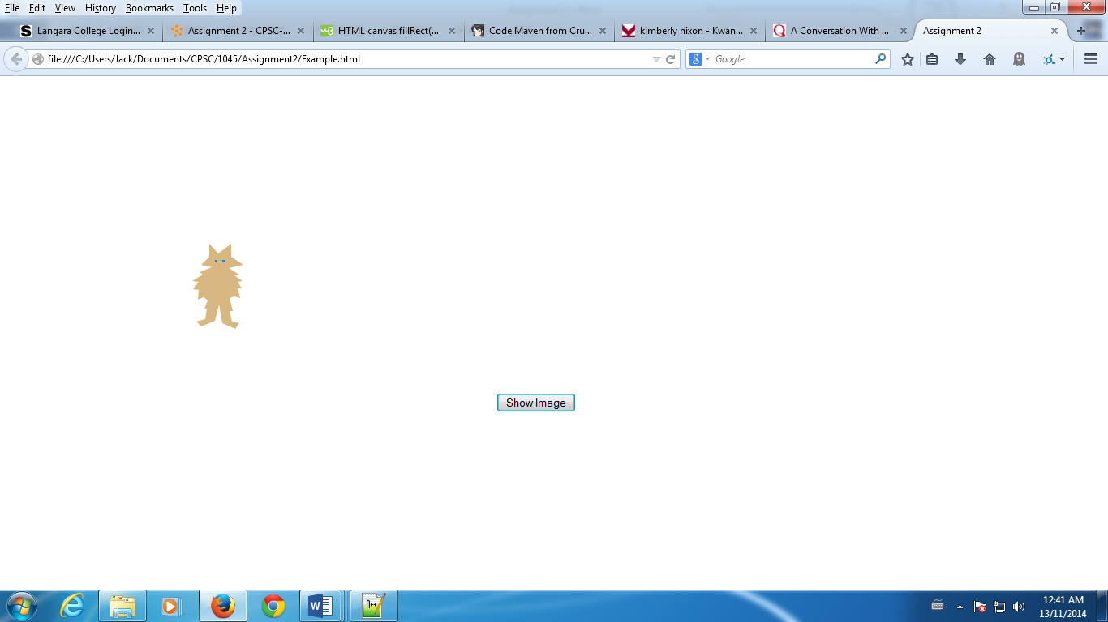

**Topics to Learn or Review**

* Events and event listeners.
* Animation – translation, transformations, etc.
* Timers (for movement).